SP Monitoring User Manual

A step by step navigational process

November 2013

Prepared by: FEi Systems

Contents

1 Accessing SP Monitoring 1

2 SP Monitoring Form 2

2.1 Add SP Monitoring Form 2

2.1.1 When client is NOT successfully contacted 3

2.1.2 When client is contacted 4

2.2 Edit SP Monitoring Form 6

2.3 Submit SP Monitoring Form 7

2.4 Discard SP Monitoring Form 8

2.5 View Discarded History 9

# Accessing SP Monitoring

To access SP Monitoring, you must login as a permitted user:

1. Log in as the permitted user
2. Search for client under *Clients* tab using “**Case**” search
3. Click **Client Summary** for client

1. Enter client information and click "Cases" button
2. Click "Client Summary" link

1. Click **SP Monitoring (under Case Management)** from left navigation

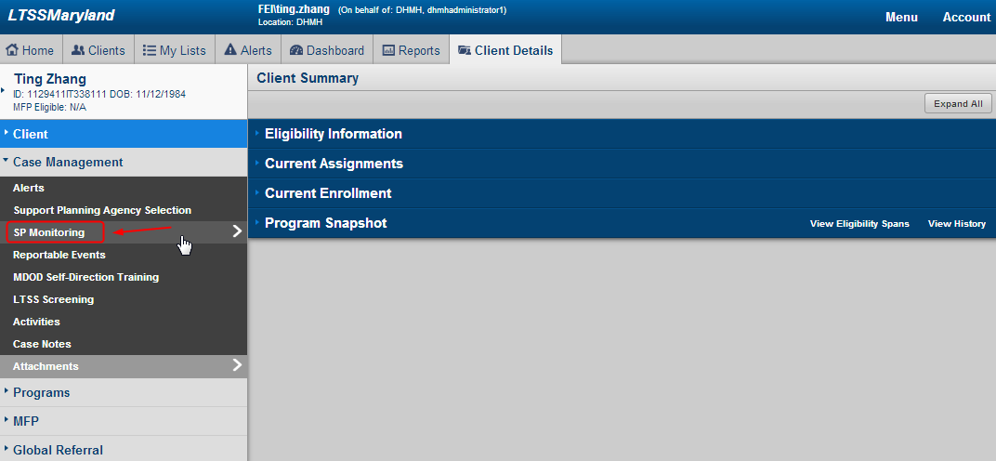

1. LTSS will bring you to SP Monitoring List Page

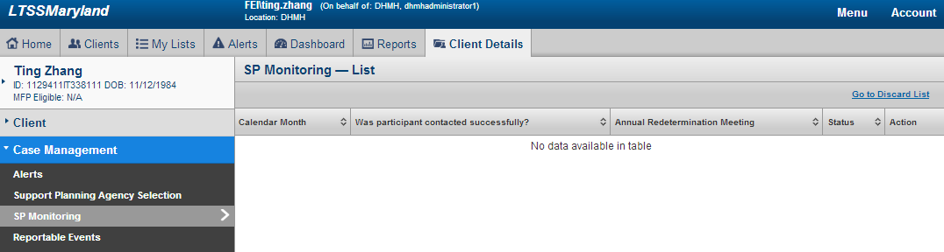

# SP Monitoring Form

## Add SP Monitoring Form

To add a SP Monitoring Form, you must login as a user from client’s current support planning agency.

1. Access SP Monitoring
2. Click “Add SP Monitoring” from SP Monitoring list page

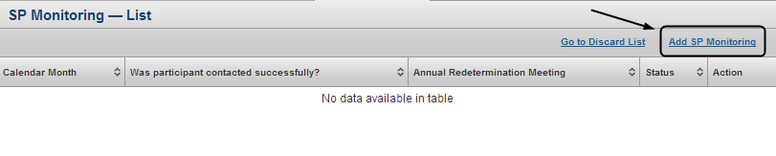

1. If client doesn’t have active enrollment, LTSS will prompt user to choose continue or cancel. Click “Yes” to continue adding SP Monitoring form, click “No” to cancel

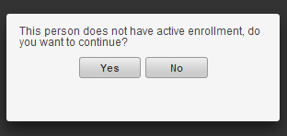

1. If choose to continue, LTSS will prompt user to enter “Calendar Month” and answer “Was Participant Contacted Successfully?”. The SP Monitoring form varies by the answer.

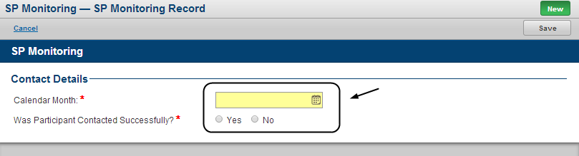

### When client is NOT successfully contacted

1. If “Was Participant Contacted Successfully?” = “No”, add attempted contact history and click “Save”

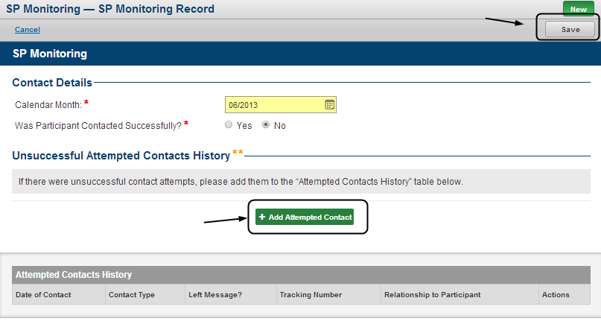

1. An “In Progress” SP Monitoring from is created

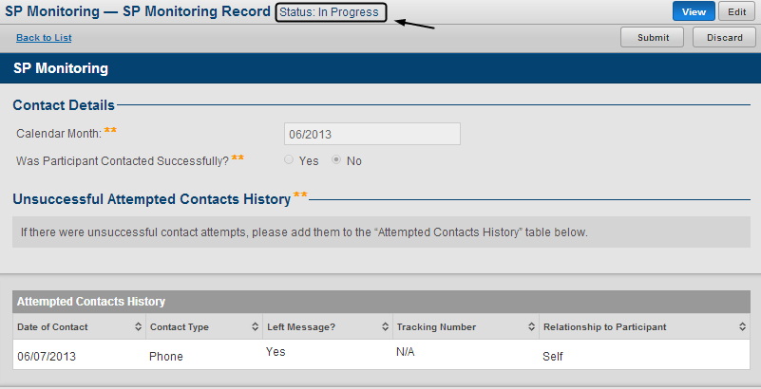

### When client is contacted

1. If “Was Participant Contacted Successfully?” = “Yes”, add contact details and attempted contact history (Optional) and click “Save”

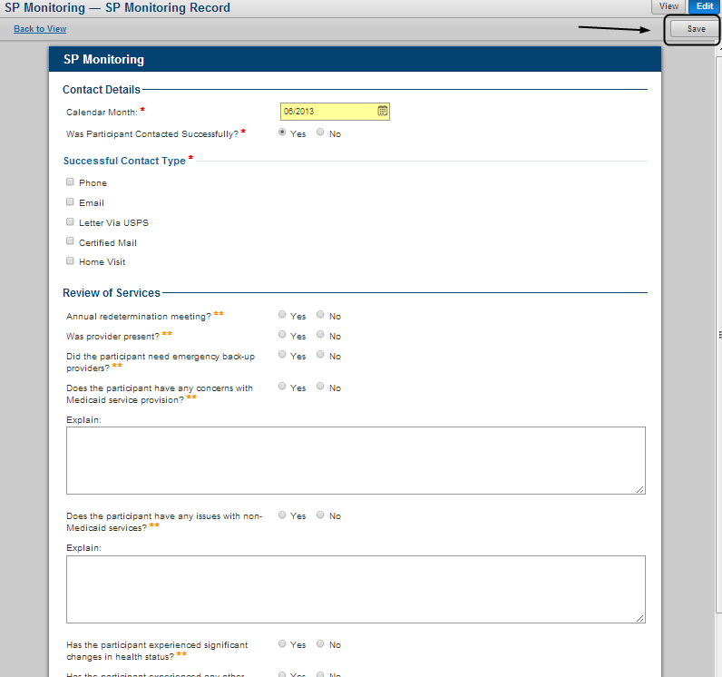

1. An “In Progress” SP Monitoring from is created

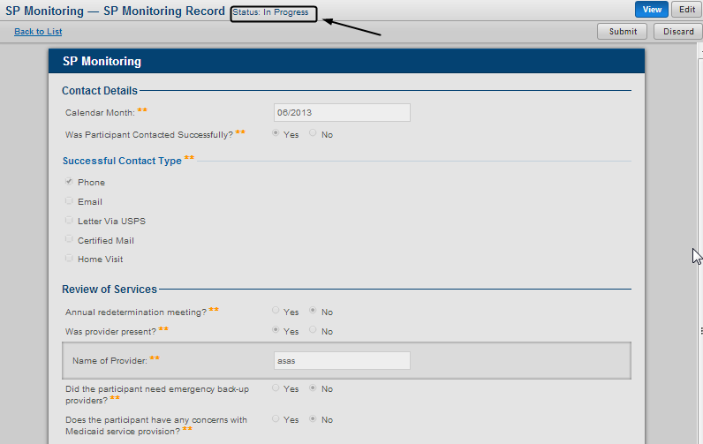

## Edit SP Monitoring Form

1. An “**In Progress**” SP Monitoring from is required for editing
2. Access SP Monitoring Form
3. Select an “In Progress” record and click “View”

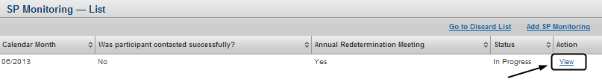

1. Click “Edit”

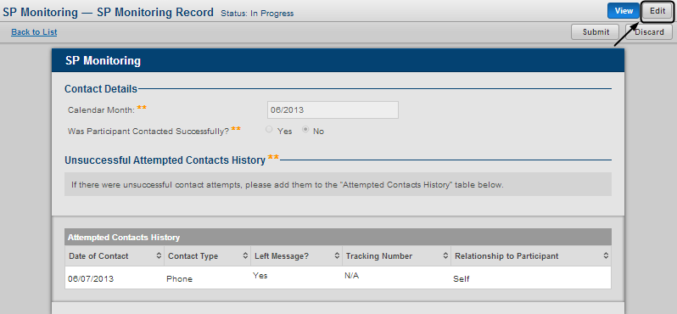

## Submit SP Monitoring Form

1. An “In Progress” SP Monitoring from is required for submitting
2. Access SP Monitoring Form
3. Select an “In Progress” record and click “View”



1. Click “Submit”

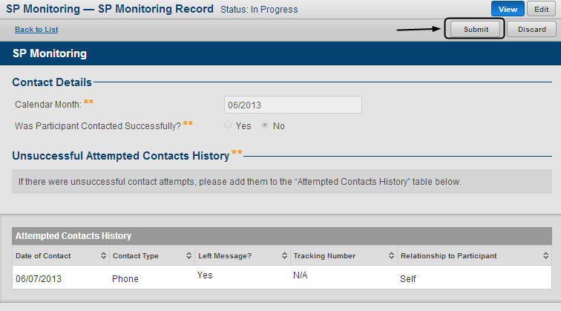

1. Once submitted, the form can no longer be edited

## Discard SP Monitoring Form

1. Access SP Monitoring Form
2. Select a record and click “View”



1. Click “Discard”

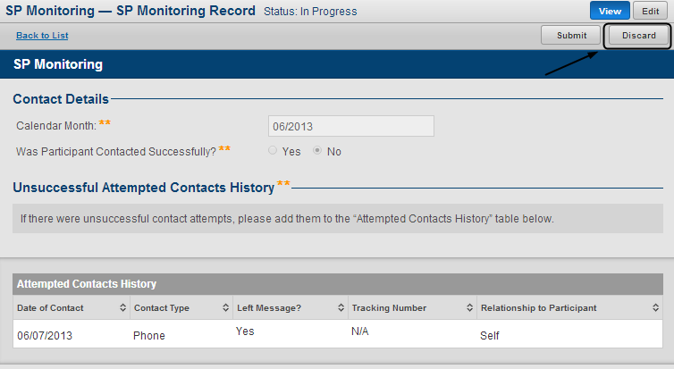

1. Enter “Comments” and click “Yes” to continue or click “No” to cancel

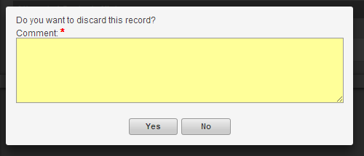

## View Discarded History

1. Access SP Monitoring
2. Click “Go to Discarded List”

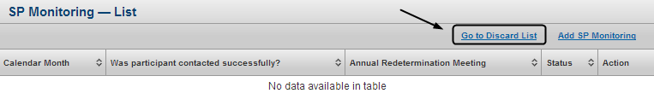

1. LTSS brings you to SP Monitoring – Discarded List. You can click “View” to view a discarded record

